PPC 125 Protocol

(Version 1.0)

Software Settings

Bidirectional :

Setup step 1 (Open parameter setting):
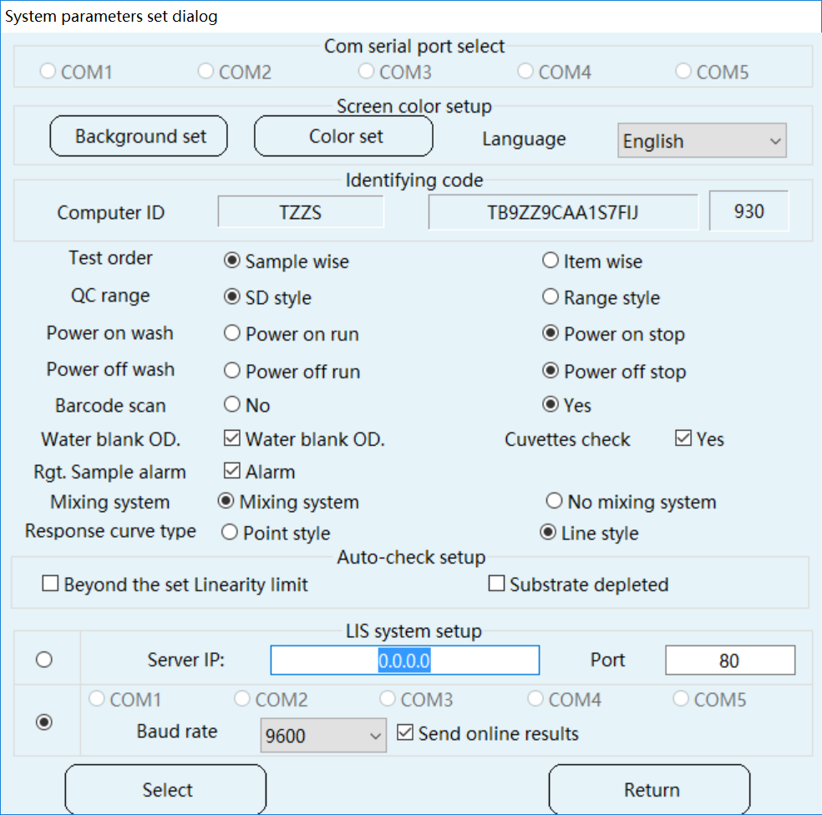
Setup step 2 (Select RS232 or TCP/IP mode):
Setup step 3:Click the button “Select” to Save the Setup
Setup step 4:Reboot the software.

Software instructions

Manually send results to LIS:

Step 1:
Go to [REPORT] screen, and select the sample ID
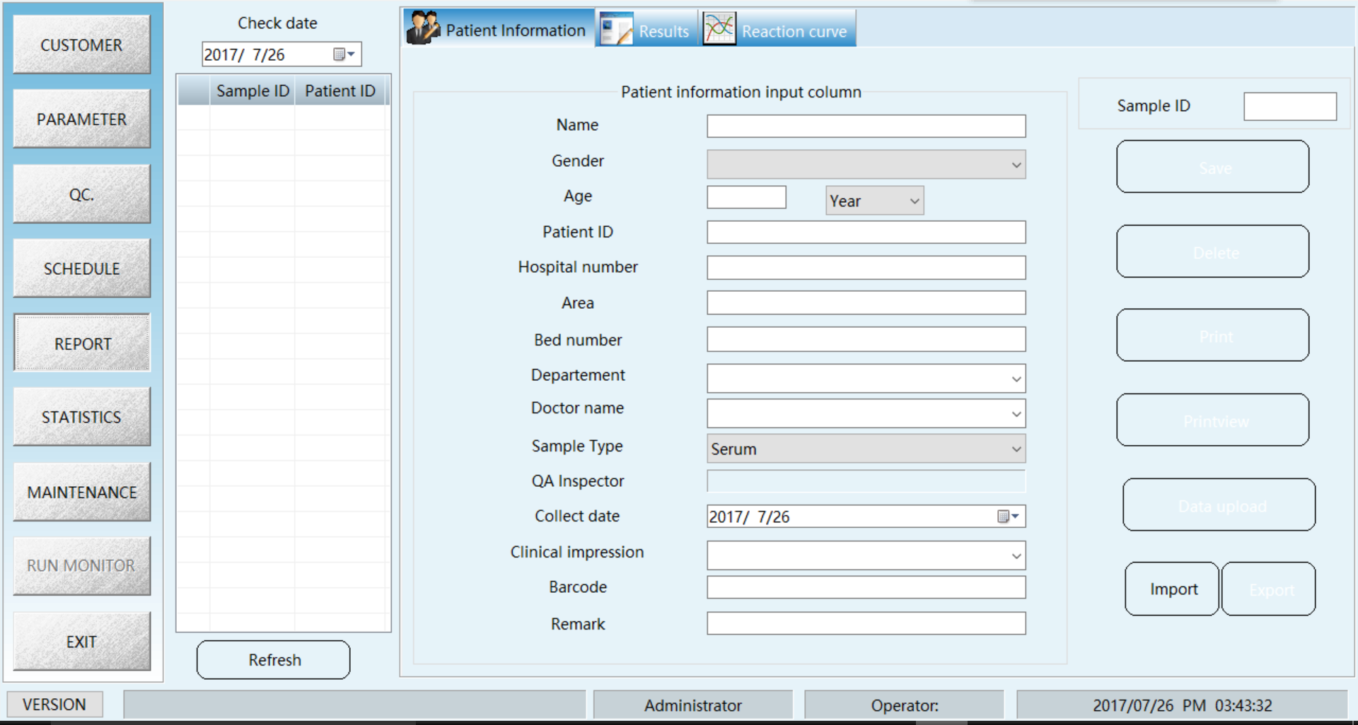
Step 2 (Click the button “Data upload”):

Apply the test from LIS:

Sample No mode:

Step 1 :
In [SCHEDULE] screen, press LIS
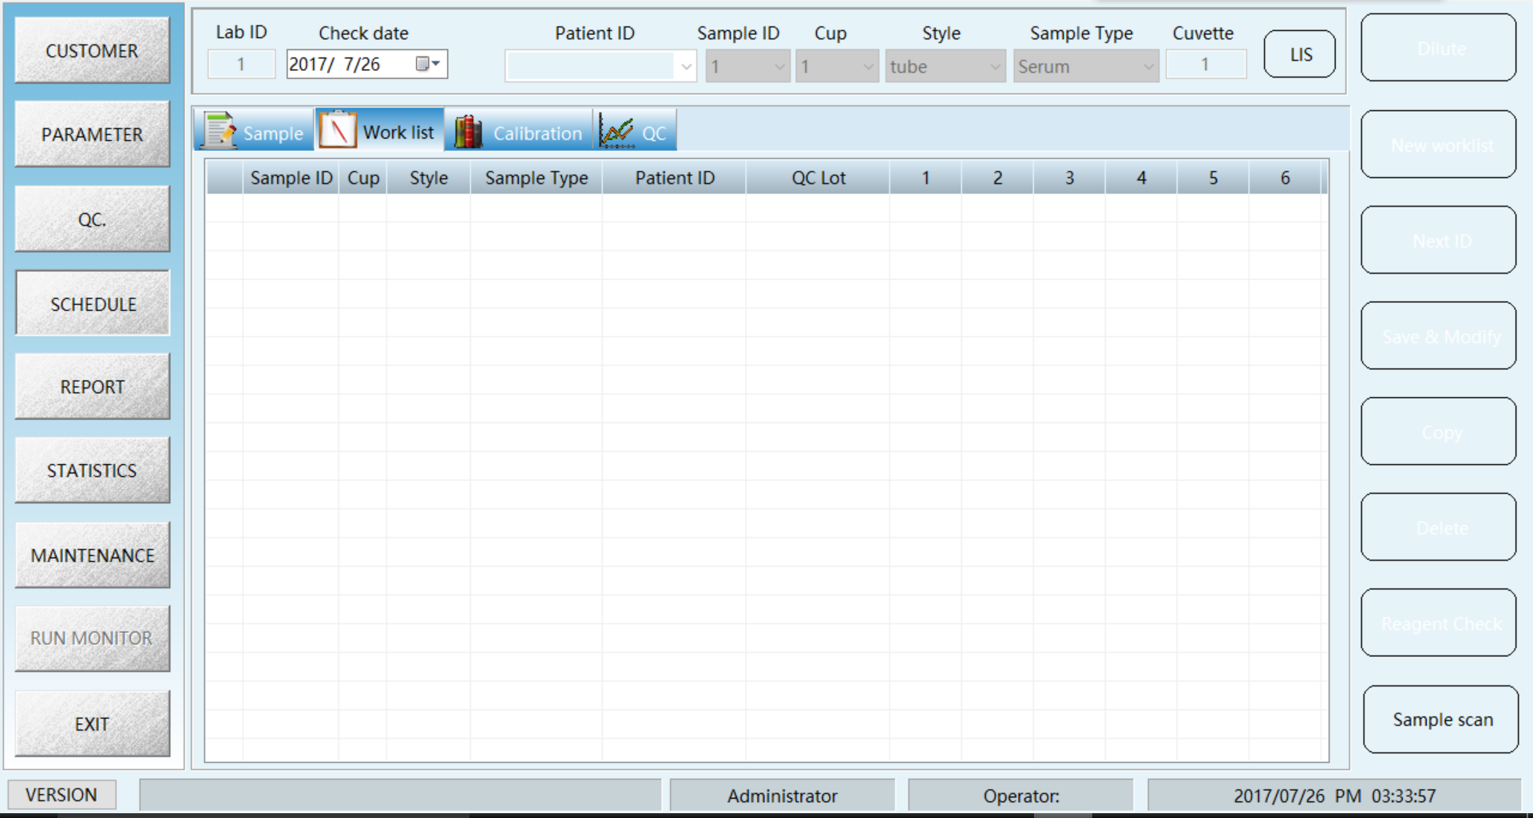
Step 2 : Select RS232 or TCP/IP mode, press [Receive]
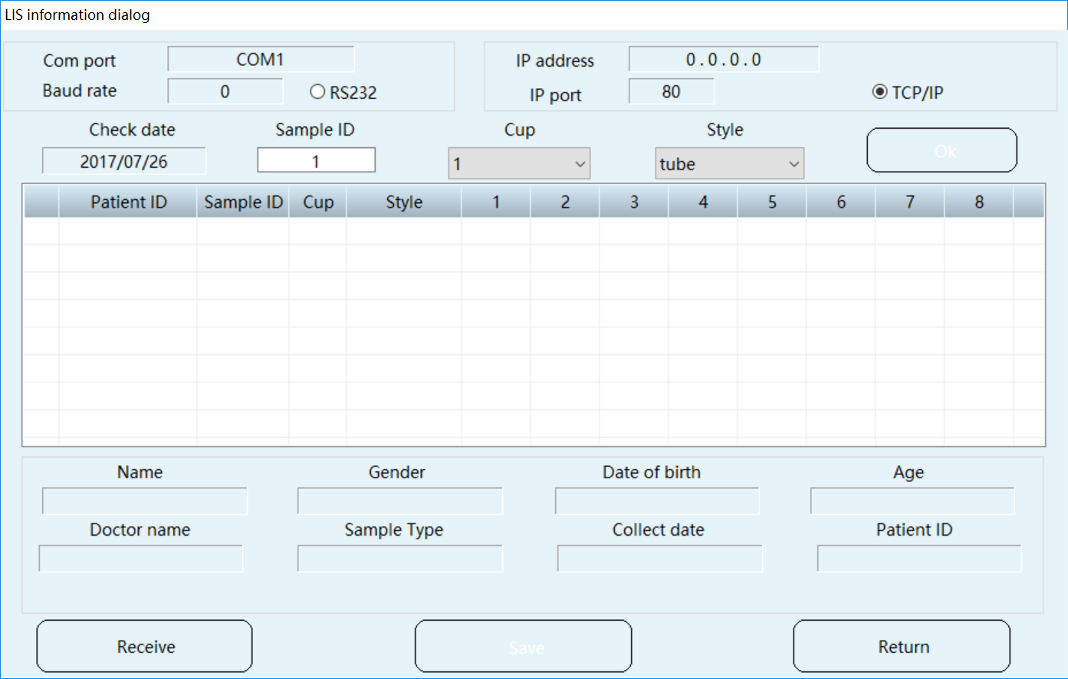
Step 3 :
Setup the cup position and tube type, then press OK, and SAVE.

BASIC LIS RELATED TERMS

1. Control Codes

LF (Line Feed) (Hex 0A)

CR (Carriage Return) (Hex 0D)

STX (Start of Text) (Hex 02)

ETX (End of Text) (Hex 03)

EOT (End of Transmission) (Hex 04)

ENQ (Enquiry) (Hex 05)

ACK (Acknowledge) (Hex 06)

NAK (Not Acknowledged) (Hex 15)

2. Message Frame / Checksum Calculation

The end frame

[STX] FN Text first char. ...... Text last char. ETX CH CL [CR] [LF]

[STX] is the ASCII code 2, indicating the beginning of a frame transmission.

FN is the frame number modulo 8. Frames of a single Transmission Phase are consecutively numbered beginning with 1. So FN runs from 1 to 7,continues with 0, 1 and so on. Use ASCII codes for the digits "0" to "7" (48-55)!

Text is the data content of a frame.

[ETX] is the ASCII code 3, indicating the end of the text block of an end frame.

CH, CL represent the high nibble (= most significant 4 bit) and the low nibble (=least significant 4 bit) of the 8 bit checksum, respectively. CH and CL are represented as two digits of hex numbers.

The checksum is the modulo 8 of the sum of ASCII values of the frame characters starting with and including "FN" and completing with [ETX].

Example for Checksum Calculation

[STX]1Test[ETX]

Symbol | Character | Value (decimal) | Sum
[STX] | [STX] | 002 | 0
FN | „1‟ | 049 | 49
Text | „T‟ | +084 | 133
 | „e‟ | +101 | 234
 | „s‟ | +115 | 349
 | „t‟ | +116 | 465
[ETX] | [ETX] | +003 | 468
 |  | 468 | = 468
 |  | MOD 256
 |  | 212 | = 212
CH | „D‟ | 068
CL | „4‟ | 052
[CR] | [CR] | 013
[LF] | [LF] | 010

to be sent:

[STX]1Test[ETX]D4[CR][LF]

Checksum is sum of transmitted character codes including from FN to [ETX] modulo 100 hex. It is an 8 bit value expressed and transmitted as a two digit hex number, most significant digit first.

3. Delimiters

The Presentation Layer uses some characters as special delimiter codes. These characters may not be used as normal message text:

Delimiter | Character | Char. | ASCII decimal | ASCII hex.
Record delimiter | = carriage return | <CR> | 13 | 0Dh
Field delimiter | = vertical bar | | | 124 | 7Ch
Repeat delimiter | = backslash | \ | 92 | 5Ch
Component delimiter | = caret | ^ | 94 | 5Eh
Escape delimiter | = ampersand | & | 37 | 26h

4. Table of Record Message Type

Record Name Identifier

Message Header Record H

Patient Information Record P

Test Order Record O

Result Record R

Message Terminator Record L

Request Information Record Q

5. Communication mode

PPC 125 is able to communicate in batch mode.

Batch Mode:

Results will be uploaded as soon as available and/or as manually selected from the result data base.

6. Communication Options

Host communication options can be found on the System Setup/Host Communication Setting/ Communication Setting screen.

Default :19200,8,N,1.

Item | Specifications
Com Port | 1~5
Baud rate | 4800,9600,19200，57600
data bit | 7,8
Parity bit | Even, Odd, None
Stop bit | 1,2

7. Data Record Usage

(refer to ASTM 1394, particularly sections 6 through 13)

Each record sent by the PPC 125 will contain up to the last field used by the PPC 125, which may or may not be all fields possible for the record. The first <Max Length> characters are significant only.Any more characters transmitted for a specific field are ignored.

Message send from PPC 125 to Host

Mandatory:

Y: Field is mandatory and have to be considered.

N: Field is not mandatory. The field have to be considered by the LIS, but it is transmitted only if information is available at Liaison. When the information is not available an empty field is transmitted.

Message Header Record (H)

Description:

The Message Header Record to the host is the first record of each message.

Example:

<STX><FN>H|\^&|||PPC 125|||||Host|||1|20081124151206<CR><ETX>[ Checksum] <CR><LF>

Field No. | E1394 | ASTM Field Name | Field Contents | Max Length | Mandatory
1 | 7.1.1 | Record Type ID | „H‟ | 1 | Y
2 | 7.1.2 | Delimiter Definition | „| \ ^ &‟ | 4 | Y
5 | 7.1.5 | Sender Name or ID | „PPC 125‟ | 20 | Y
10 | 7.1.10 | Receiver ID |  | 20 | Y
13 | 7.1.13 | Version No. | „1‟ | 1 | Y
14 | 7.1.14 | Date and Time of Message | „YYYYMMDDHHMMSS‟ | 14 | Y

Patient Information Record (P)

Description:

This record is used to transfer patient sex and age to the host (within result message).

Example:

<STX><FN>P|1||||ZhangDongdong|||M||||||40^Y<CR><ETX>[ Checksum] <CR><LF>

Field No. | E1394 | ASTM Field Name | Field Contents | Max Length | Mandatory
1 | 8.1.1 | Record Type ID | „P‟ | 1 | Y
2 | 8.1.2 | Sequence Number |  | 6 | Y
6 | 8.1.6 | Patient Name |  | 30 | N
9 | 8.1.9 | Patient Sex | „M‟, „F‟or „U‟ | 1 | N
15^1 | 8.1.15 | Special Field 1 | Age (1-200) | 3 | N
15^2 | 8.1.15 | Special Field 1 | Age Unit („Y‟,‟M‟,‟D‟) | 1 | N

Test Order Record (O)

Description:

This record holds information regarding analysis request and sample information to the host (within result message).

Example:

S.No Mode :

<STX><FN>O|1|^1^1^10^N|||R|20081124151012|||||||||1||||||||||O

<CR><ETX><CheckSum><CR><LF>

Sample ID Mode:

<STX><FN>O|1|CA2201320078^^1^10^N|||R|20081124151012|||||||||1||||||||||O<CR><ETX><Chec

kSum><CR><LF>

Field No. | E1394 | ASTM Field Name |  | Valid Contents | Max Length | Mandatory
1 | 9.4.1 | Record Type ID |  | „O‟ | 1 | Y
2 | 9.4.2 | Sequence Number |  |  | 6 | Y
3^1 |  | Specimen ID |  | Sample ID (ID Mode) | 22
 |  | (<Sample ID>^
3^2 |  | (<Sample ID>^ | Sample No. (S. No. Mode) |  | 6
3^2 |  | <Sample No>^ |  |  | 6
3^3 | 9.4.3 | <Sample No>^ |  | Disk No. | 1 | Y
3^3 | 9.4.3 | <Disk ID>^ |  | Disk No. | 1 | Y
3^4 |  | <Disk ID>^ |  | Position No. | 2
3^4 |  | <Position No>^ |  | Position No. | 2
3^5 |  | <Diluent>) |  | „Y‟ or „N‟ | 1
6 | 9.4.6 | Priority |  | „S‟ or ‟R‟ | 1 | Y
7 | 9.4.7 | Requested/Ordered | „YYYYMMDD HHMMSS‟ |  | 14 | Y
7 | 9.4.7 | Date and Time |  |  | 14 | Y
 |  |  | 1 | - Serum
 |  |  | 2 | - Urine
16 | 9.4.16 | Specimen Descriptor | 3 | - CSF | 1 | Y
 |  |  | 4 | - Suprnt
 |  |  | 5 | - Others
26 | 9.4.26 | Report Types | „O‟, „F‟, „I‟, „C‟ or „X‟ |  | 1 | Y

Result Record (R)

Description:

The Result Record to the host contains the result of a single analytical determination.

Example:

<STX><FN>R|1|^^^GGT|4.96|mg/dL|3^12\0^20|N||F||||20081124151012

<CR><ETX><CheckSum><CR><LF>

Field No. | E 1394 | ASTM Field Name | Field Contents | Max Length | Mandatory
1 | 10.1.1 | Record Type ID | R | 1 | Y
2 | 10.1.2 | Sequence Number |  | 5 | Y
3 | 10.1.3 | Universal Test ID |  | 10 | Y
4 | 10.1.4 | Data or Measurement Value |  | 12 | N
5 | 10.1.5 | Units |  | 10 | N
 |  |  | first range = normal
6 | 10.1.6 | Reference Ranges | range second range = | 30 | N
6 | 10.1.6 | Reference Ranges | critical range separated | 30 | N
 |  |  | by repeat delimiter ('\')
7 | 10.1.7 | Result Abnormal Flags | „L‟,‟H‟,‟N‟ or ‟A‟ | 1 | N
9 | 10.1.9 | Result Status | „F‟ or „C‟ | 1 | Y
13 | 10.1.13 | Date/Time Test Completed | „YYYYMMDDHHMMSS‟ | 14 | N

Request Information Record to Host

Description:

The Request Information Record to the host is used to request sample program information from the host computer. A query is typically performed when a sample bar code has been read on the instrument and no sample program information is found locally. All queries are made by sample ID.

Example:

S.No Mode:<STX><FN>Q|1|^1^0^1^N| |ALL||||||||O<CR><CTX><CheckNum><CR><LF>

Sample ID Mode:<STX><FN>Q|1|AC2201023321^^0^1^N| |ALL||||||||O<CR><CTX><CheckNum><CR><LF>
Field No. | E1394 | ASTM Field Name | Field Contents | Max Length | Mandatory
1 | 10.1.1 | Record Type ID | „Q‟ | 1 | Y
2 | 10.1.2 | Sequence Number |  | 6 | Y
3^1 |  | Starting Range ID Number | Sample ID (ID Mode) | 22
 |  | (<Sample ID>^
3^2 |  | (<Sample ID>^ | Sample No. (S. No. Mode) | 6
3^2 |  | <Sample No>^ | Sample No. (S. No. Mode) | 6
3^3 | 10.1.3 | <Sample No>^ | Disk No. | 1 | Y
3^3 | 10.1.3 | <Disk ID>^ | Disk No. | 1 | Y
3^4 |  | <Disk ID>^ | Position No. | 2
3^4 |  | <Position No>^ | Position No. | 2
3^5 |  | <Diluent>) | „Y‟ or „N‟ | 1
5 | 10.1.5 | Universal Test ID | „ALL‟ |  | Y
13 | 10.1.13 | Request Information Status Codes | „A‟ or „O‟ | 1 | Y

Message Terminator Record

Description:

The Message Terminator Record to the host is used with the Message Header Record to encapsulate related patient information.

Example:

<STX><FN>L|1|N<CR><ETX><CheckNum><CR><LF>

Field No. | E1394 | ASTM Field Name | Field Contents | Max Length | Mandatory
1 | 13.1.1 | Record Type ID | „L‟ | 1 | Y
2 | 13.1.2 | Sequence Number |  | 6 | Y
3 | 13.1.3 | Termination Code | „N‟ | 1 | Y

Message send from Host to PPC 125

Mandatory: Y: Field is mandatory and have to be considered.

N: Field is not mandatory. The field have to be considered by the LIS, but it is transmitted only if information is available at Liaison. When the information is not available an empty field is transmitted.

Message Header Record (H)

Description:

The Message Header Record to the analyzer is the first record of each message.

Example:

<STX><FN>H|\^&<CR><ETX>[ Checksum] <CR><LF>

Field No. | E1394 | ASTM Field Name | Field Contents | Max Length | Mandatory
1 | 7.1.1 | Record Type ID | „H‟ | 1 | Y
2 | 7.1.2 | Delimiter Definition | „| \ ^ &‟ | 4 | Y

Patient Information Record (P)

Description:

This record is used to transfer patient sex and age to the analyzer (within test selection message).

Example:

<STX><FN>P|1||123456||ZhangDongdong|||M||||||40^Y<CR><ETX>[Checksum] <CR><LF>

Field No. | E1394 | ASTM Field Name | Field Contents | Max Length | Mandatory
1 | 8.1.1 | Record Type ID | „P‟ | 1 | Y
2 | 8.1.2 | Sequence Number |  | 6 | Y
4 | 8.1.4 | Laboratory Assigned Patient ID | Sample ID or Sample No. | 22 | N
6 | 8.1.6 | Patient Name |  | 30 | N
9 | 8.1.9 | Patient Sex | „M‟, „F‟ or „U‟ | 1 | N
15^1 | 8.1.15 | Special Field 1 | Age (1-200) | 3 | N
15^2 | 8.1.15 | Special Field 1 | Age Unit („Y‟,‟M‟,‟D‟) | 1 | N

Test Order Record (O)

Description:

This record holds information regarding analysis request and sample information to the analyzer (within test selection message).

Example:

<STX><FN>O|1|AB2201022318^^1^10^N||^^^ALT|R|20081124151012|||||||||1||||||||||O<CR><ETX

><CheckNum><CR><LF>

Field No. | E1394 | ASTM Field Name |  | Valid Contents | Max Length | Mandatory
1 | 9.4.1 | Record Type ID |  | „O‟ | 1 | Y
2 | 9.4.2 | Sequence Number |  |  | 6 | Y
3^1 |  | Specimen ID |  | Sample ID (ID Mode) | 22
 |  | (<Sample ID>^
3^2 |  | (<Sample ID>^ | Sample No. (S. No. Mode) |  | 6
3^2 |  | <Sample No>^ |  |  | 6
3^3 | 9.4.3 | <Sample No>^ |  | Disk ID | 1 | Y
3^3 | 9.4.3 | <Disk ID>^ |  | Disk ID | 1 | Y
3^4 |  | <Disk ID>^ |  | Position No. | 2
3^4 |  | <Position No>^ |  | Position No. | 2
3^5 |  | <Diluent>) |  | „Y‟ or „N‟ | 1
5 | 9.4.5 | Universal Test ID |  |  | 10 | Y
6 | 9.4.6 | Priority |  | „S‟ or ‟R‟ | 1 | N
7 | 9.4.7 | Requested/Ordered |  | „YYYYMMDD HHMMSS‟ | 14 | N
7 | 9.4.7 | Date and Time |  | „YYYYMMDD HHMMSS‟ | 14 | N
 |  |  | 1 | - Serum
 |  |  | 2 | - Urine
16 | 9.4.16 | Specimen Descriptor | 3 | - CSF | 1 | N
 |  |  | 4 | - Suprnt
 |  |  | 5 | - Others
26 | 9.4.26 | Report Types | ‘O’,‘F’,‘I’,‘C’ or „X‟ |  | 1 | N

Message Terminator Record

Description

The Message Terminator Record to the analyzer is used with the Message Header Record to encapsulate related patient information.

Example:

<STX><FN>L|1|N<CR><ETX><CheckNum><CR><LF>

Field No. | E1394 | ASTM Field Name | Field Contents | Max Length | Mandatory
1 | 13.1.1 | Record Type ID | „L‟ | 1 | Y
2 | 13.1.2 | Sequence Number |  | 6 | Y
3 | 13.1.3 | Termination Code | „N‟ or ‟I‟ | 1 | Y

Notice：

When the double direction communication apply the testing from the PPC 125 To Lis system，If when the lis system didn‟f find the sample that should be applied,must be send:

ENQ

EOT

Examples

1. Result Message from PPC 125 to Host

PPC 125 [ENQ]

HOST [ACK]

PPC 125 [STX]1H|\^&|||PPC 125|||||Host||1|20090119131415[CR] [ETX]24[CR][LF]

HOST [ACK]

PPC 125 [STX] 2P|1|||||||||||||^[CR][ETX]E9 [CR][LF] HOST [ACK]

PPC 125 [STX] 3O|1|128123^1^1^2|||R|20090119123027|||||||||1||||||||||O [CR][ETX]55[CR][LF]

HOST [ACK]

PPC 125 [STX] 4R|1|^^^ALT|-2|U/L|^\^|N||F||||20090119123027[CR] [ETX]32[CR][LF]

HOST [ACK]

PPC 125 [STX] 5R|2|^^^AST|1|U/L|^\^|N||F||||20090119123027[CR] [ETX]0D[CR][LF]
HOST [ACK]

PPC 125 [STX] 6R|3|^^^ALB|-8.57|g/l|^\^|N||F||||20090119123027[CR] [ETX]F6[CR][LF]

HOST [ACK]

PPC 125 [STX] 7L|1|N[CR][ETX]0A[CR][LF] HOST [ACK]

PPC 125 [EOT]

2. Request from PPC 125 to Host

Single:

PPC 125 [ENQ]

HOST [ACK]

PPC 125 [STX]1H|\^&|||PPC 125|||||Host||1|20090119131335[CR]

[ETX]25[CR][LF]

HOST [ACK]

PPC 125 [STX] 2Q|1|^130^5^45^N||ALL||||||||O[CR][ETX]B4[CR][LF]

HOST [ACK]

PPC 125 [STX] 3L|1|N[CR][ETX]06[CR][LF] HOST [ACK]

PPC 125 [EOT]

Batch:

PPC 125 [ENQ]

HOST [ACK]

PPC 125 [STX]1H|\^&|||PPC 125|||||Host||1|20090119131335[CR] [ETX]25[CR][LF]

HOST [ACK]

PPC 125 [STX] 2Q|1|^11^2^11^N||ALL||||||||O[CR][ETX]78[CR][LF] HOST [ACK]

PPC 125 [STX] 3Q|2|^12^2^12^N||ALL||||||||O[CR][ETX]7C[CR][LF] HOST [ACK]

PPC 125 [STX] 4Q|3|^13^2^13^N||ALL||||||||O[CR][ETX]80[CR][LF] HOST [ACK]

PPC 125 [STX] 5Q|4|^14^2^14^N||ALL||||||||O[CR][ETX]84[CR][LF] HOST [ACK]

PPC 125 [STX] 6L|1|N[CR][ETX]09[CR][LF] HOST [ACK]

PPC 125 [EOT]

3. Test order from Host to PPC 125

Sample ID mode:

Single:

HOST [ENQ] PPC 125 [ACK]

HOST [STX] 1H|\^&[CR][ETX]E5[CR][LF] PPC 125 [ACK]

HOST [STX] 2P|1|||||||||||||^[CR][ETX]E9[CR][LF] PPC 125 [ACK]

HOST [STX] 3O|1|3977777^4^1^1^N||^^^AST|R|20090119100534||||||||

|1||||||||||O[CR][ETX]51[CR][LF] PPC 125 [ACK]

HOST [STX] 4O|2|3977777^4^1^1^N||^^^TP|R|20090119100534|||||||| |1||||||||||O[CR][ETX]0F[CR][LF]
PPC 125 [ACK]

HOST [STX] 5O|3|3977777^4^1^1^N||^^^ALB|R|20090119100534|||||||| |1||||||||||O[CR][ETX]3C[CR][LF]

PPC 125 [ACK]

HOST [STX] 6L|1|N[CR][ETX]09[CR][LF] PPC 125 [ACK]

HOST [EOT]

Batch:

HOST [ENQ] PPC 125 [ACK]

HOST [STX] 1H|\^&[CR][ETX]E5[CR][LF] PPC 125 [ACK]

HOST [STX] 2P|1|||||||||||||^[CR][ETX]E9[CR][LF] PPC 125 [ACK]

HOST [STX] 3O|1|128123^1^1^1^N||^^^ALT|R|20090119100417|||||||| |1||||||||||O[CR][ETX]F9[CR][LF]
PPC 125 [ACK]

HOST [STX] 4O|2|128123^1^1^1^N||^^^AST|R|20090119100417|||||||| |1||||||||||O[CR][ETX]02[CR][LF]

PPC 125 [ACK]

HOST [STX] 5L|1|N[CR][ETX]08[CR][LF] PPC 125 [ACK]

HOST [STX] 1H|\^&[CR][ETX]E5[CR][LF] PPC 125 [ACK]

HOST [STX] 2P|1|||||||||||||^[CR][ETX]E9[CR][LF] PPC 125 [ACK]

HOST [STX] 3O|1|1281234^2^1^2^N||^^^ALT|R|20090119100425|||||||| |1||||||||||O[CR][ETX]2E[CR][LF]
PPC 125 [ACK]

HOST [STX] 4O|2|1281234^2^1^2^N||^^^ALB|R|20090119100425|||||||| |1||||||||||O[CR][ETX]1E[CR][LF]

PPC 125 [ACK]

HOST [STX] 5L|1|N[CR][ETX]08[CR][LF] PPC 125 [ACK]

HOST [STX] 1H|\^&[CR][ETX]E5[CR][LF] PPC 125 [ACK]

HOST [STX] 2P|1|||||||||||||^[CR][ETX]E9[CR][LF] PPC 125 [ACK]

HOST [STX] 3O|1|3977777^4^1^3^N||^^^AST|R|20090119100534|||||||| |1||||||||||O[CR][ETX]53[CR][LF]
PPC 125 [ACK]

HOST [STX] 4O|2|3977777^4^1^3^N||^^^TP|R|20090119100534|||||||| |1||||||||||O[CR][ETX]11[CR][LF]
PPC 125 [ACK]

HOST [STX] 5O|3|3977777^4^1^3^N||^^^ALB|R|20090119100534|||||||| |1||||||||||O[CR][ETX]3E[CR][LF]

PPC 125 [ACK]

HOST [STX] 6L|1|N[CR][ETX]09[CR][LF] PPC 125 [ACK]

HOST [EOT]

